State of Colorado

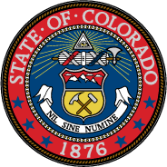

Meeting of Colorado’s Presidential Electors
Office of the Governor, Colorado State Capitol
12:00 p.m. December 19, 2016

Agenda

- Call to Order………………………………. Honorable Donna Lynne

Lieutenant Governor

- Roll Call of Electors………………………. Honorable Wayne W. Williams
Secretary of State

- Oath of Office……………………………… Honorable Nancy E. Rice
Chief Justice, Colorado Supreme Court

- Electors Escorted to Capitol’s West Foyer

- Introductory Remarks……………………... Honorable Donna Lynne
Lieutenant Governor

- Introductory Remarks……………………….Honorable Wayne W. Williams
Secretary of State

- Casting of Ballots…………………………. Presidential Electors

- Counting of Votes…………………………. Judd Choate
Elections Director

- Certification of Votes……………………… Honorable Wayne W. Williams
Secretary of State

- Adjournment………………………………. Honorable Donna Lynne Lieutenant Governor

